To set up Jenkins dashboard with the help of war

sudo su -

yum install java-11-amazon-corretto.x86_64 –y

cd /mnt

mkdir server

cd server

wget <https://dlcdn.apache.org/tomcat/tomcat-9/v9.0.89/bin/apache-tomcat-9.0.89.zip>

unzip apache-tomcat-9.0.89.zip

rm -rf apache-tomcat-9.0.89.zip

cd apache-tomcat-9.0.89/

chmod -R 777 apache-tomcat-9.0.89/

cd apache-tomcat-9.0.89/

cd bin/

./startup.sh

cd ..

cd webapps/

wget <https://get.jenkins.io/war-stable/latest/jenkins.war>

=================================================================================

GO TO JENKINS DASHBOARD AND CREATE JOB …

BY USING DECLARATIVE PIPELINE :

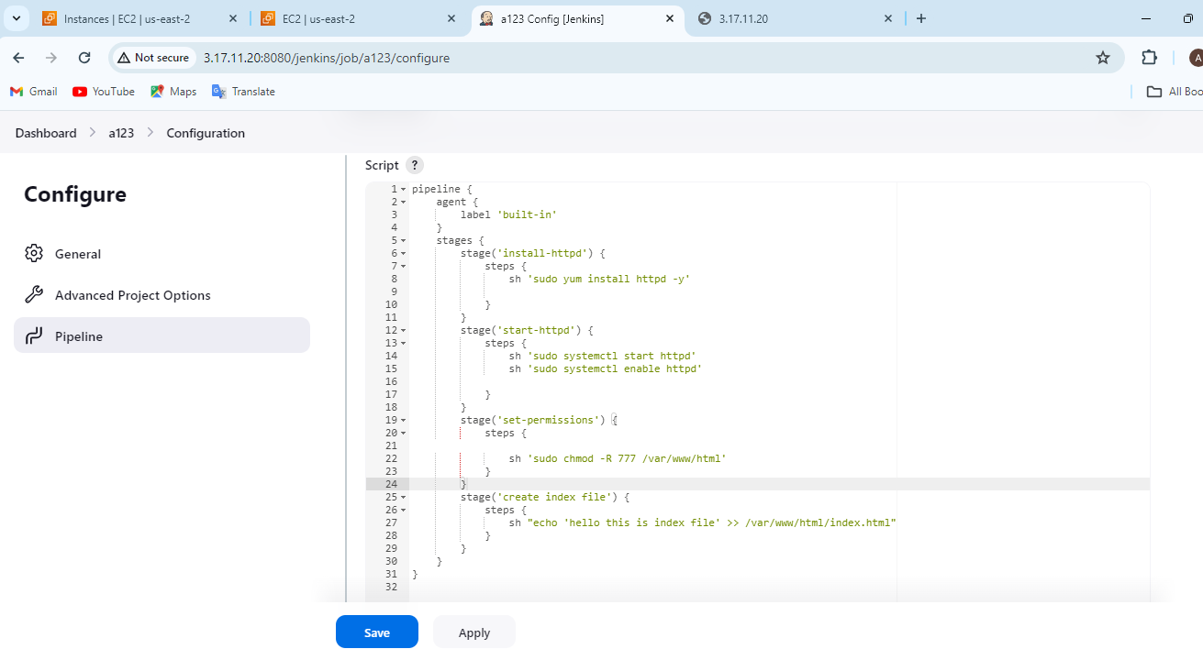

OUTPUT :





